REQUESTING ACCESS TO RATIONAL TOOLS

1/25/2013

For Contract Employees without GSA WAN Access:

Contact your Rational Project Leader or COTR – “Contracting Officer’s Technical Representative”. They will input the request on your behalf

Project Leader or COTR: See “Creating an Access Request on Behalf of an Employee”

For Government Employees or Contract Employees with GSA WAN Access:

Government employees with active ENT accounts and access to the GSA WAN may request access to Rational Tools by utilizing the Employee Access Request System (EARS).

Using EARS to Self-Request Access

Go to url: https://ears.ocfo.gsa.gov/ears/faces/home.jsp

Log on using your ENT credentials

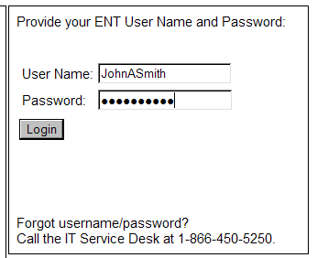

Click on the ‘Access Requests’ tab

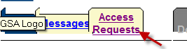

To Request Access:

Fill in the required fields.
Note: System, Subsystem and Role are linked so you must do these in order.
If you are unsure or cannot find the role (access) you want, see your manager or Rational project lead

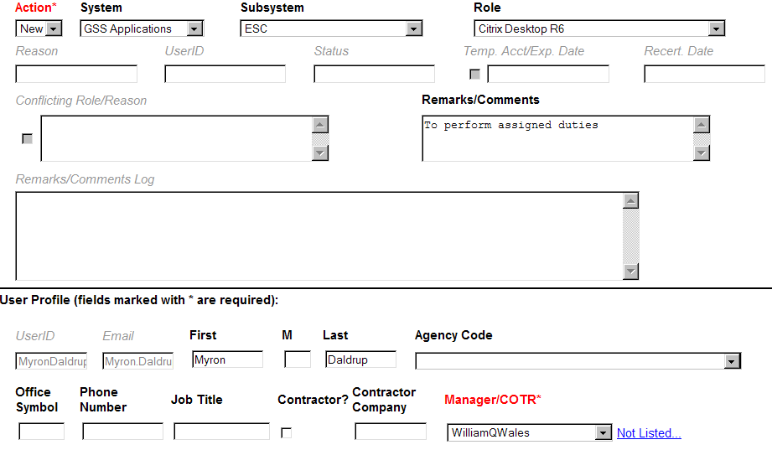

If this is your first time using the system, you will also need to fill out the security information fields.

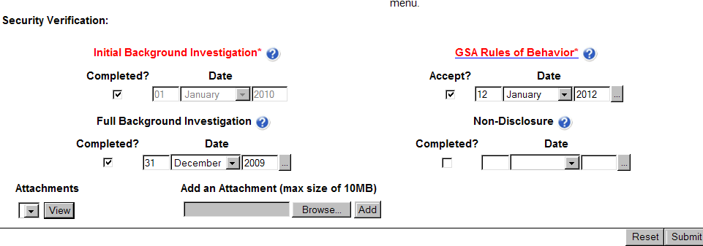

Click Submit at the bottom of the form.

Entering an Access Request on Behalf of an Employee

Go to url: https://esc.finance.gsa.gov/cqweb/login

Log on using your ENT credentials with “Production“as the Schema Repository and “ESC01 : Production Database” as the Database.

Click the Login button.

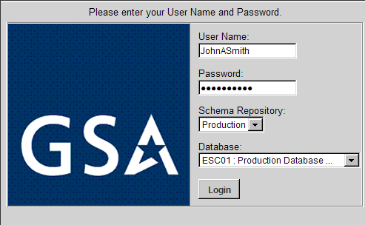

Creating a New Employee Record

{NOTE: If the employee already exists in the application, skip this section and go to “Creating an Access Request on Behalf Of”.}

Click on the ‘down arrow’ next to “New Change_Proposal”.
Highlight “OCFOUser” record type and click the “Create” button.

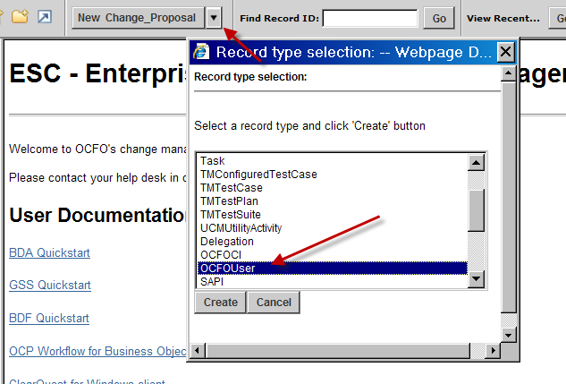

On the “Main” tab, enter the employee’s information in the “Non-ESC” section.
All fields are required with the exception of middle initial, if the employee does not have one.

Choose the manager from the “Manager/COTR (Existing)” dropdown. If the manager does not exist in the list:
Fill out the “Manager\COTR (New)” sections
All fields are required with the exception of middle initial, if the person does not have one.

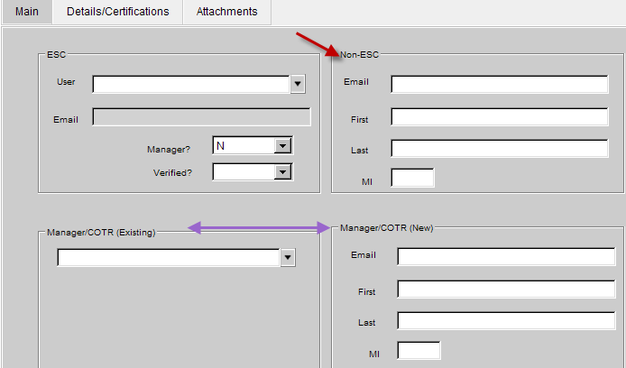

Click on the “Details/Certifications” tab

If the user is a contract employee:
The “Contractor’ box MUST be checked
Fill out the “Contractor Company” field
Choose answer for “Non Disclosure” and its corresponding date

For all employees:
The fields at the top of the screen for “Job Title”, “Agency”, “Region Code”, etc are not mandatory but can be used.

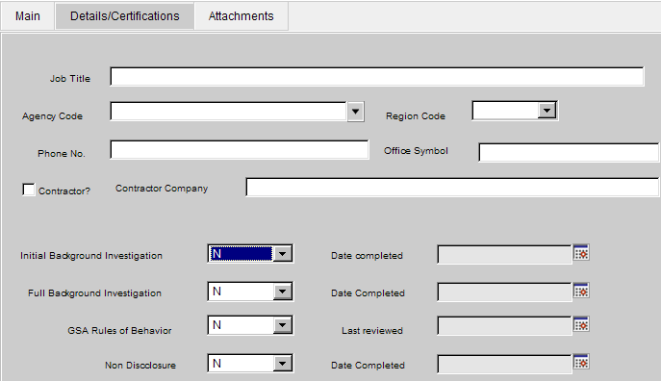

When finished with all input, click the “Save” button in the upper left corner.

Creating an Access Request on Behalf Of

Click on the ‘down arrow’ next to “New Change_Proposal”.
Highlight “Access_Request” and click the Create button.

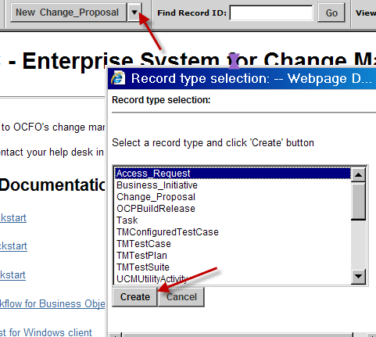

When the form opens:
- Choose the employee from the ‘Access For’ dropdown
- Choose the values from the two dropdowns for ‘System/Subsys’
- Choose the ‘Access Role’ from the provided dropdown
NOTE: The ‘System’ choice determines the list of ‘Subsys’ choices and both of these determine the list of ‘Access Roles’.
- Choose the ‘Reason’ from the provided dropdown
You may put additional information in the second ‘Reason’ field and in the ‘New Note’ field of the “Notes” tab, but they are not required.
- Click the “Save” button in the upper left corner.

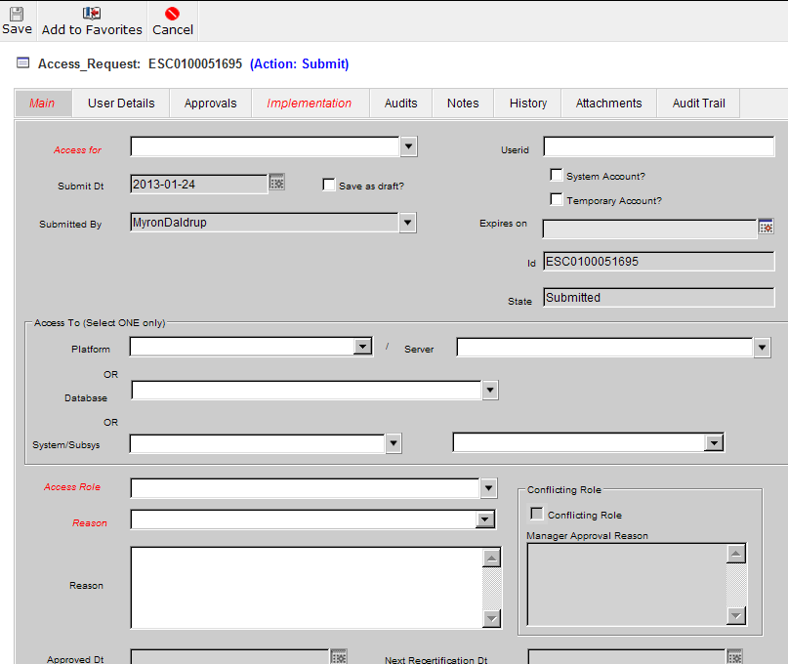

Access Request Approval Process

The following steps explain the Access Request approval process.

Step 1 – Employee or ‘On-Behalf’ representative submits an access request for the individual. An email notification is sent to the manager or COTR listed in the employee’s profile.
Step 2 - The manager/COTR approves the access request. The request is sent to the System Manager.
Step 3 -The System Manager approves the access request. The request is sent to the ISSO team.
Step 4 - An ISSO team member approves the access request. The request is sent to the Implementation team.
Step 5 –The Implementation team creates the account and notifies the user via an e-mail notification.
Step 6 – The user verifies that they can access the application.
Step 7 – Either by the employee or by the person who submitted the access request, the following is done:
- Log back onto the application in which the Access Request was submitted (EARS or ClearQuest ESC01)
- Open the Access Request
- ‘Change the State’ to issue a ‘Verify-Active’ action

This action will show that the access request is complete.

