JOINING A PROJECT/CREATING A VIEW

Log onto the Citrix server and choose the R6 Rational Desktop icon
Once on the desktop, open ClearCase

If not already chosen, choose the ‘Toolbox’ tab at the bottom of the left pane
Choose ‘UCM’ in the dropdown
Click on ‘Join Project’

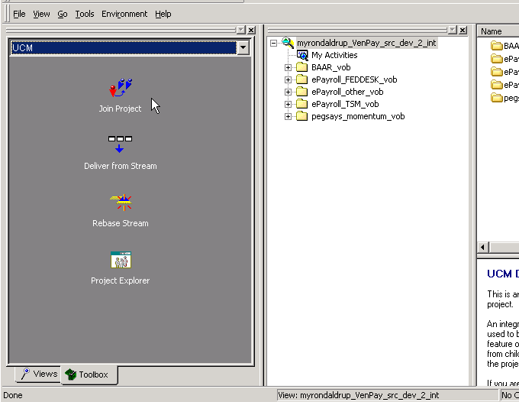

At the first window, click the box for ‘Show all Project VOBs’
Navigate to and highlight the project under the project vob
(Example Below: ‘Pegasys_momentum_pvob’ is the vob and ‘peg_qa2_prj’ is the project.)
Click ‘Next’

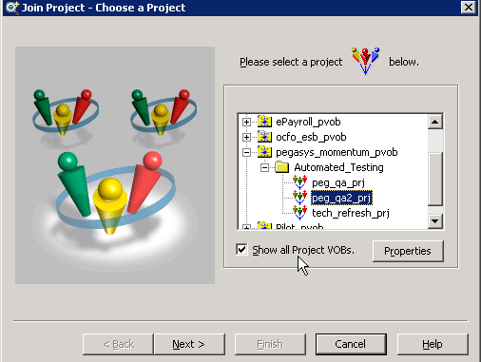

At the next window, choose the view type (Usually will be ‘Snapshot’)
Click ‘Next’
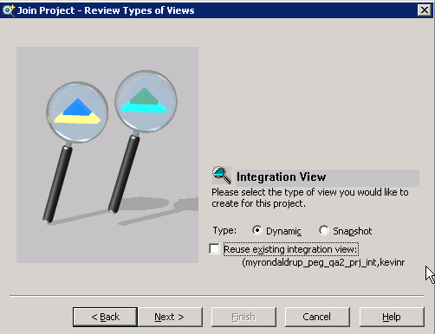

The view name will automatically have the user's ENT name. If not already in lowercase, that name must be changed to all lowercase letters.
Example: The tool created 'MyronDaldrup_peg_qu2_prj', which must be typed over to be 'myrondaldrup_peg_qu2_prj'
Choose a drive letter or ‘none’.

Click ‘OK’ to created the view
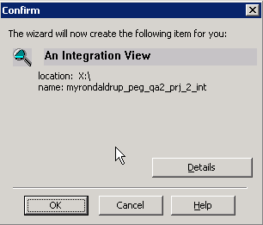

Clear the confirmation window by clicking ‘OK’
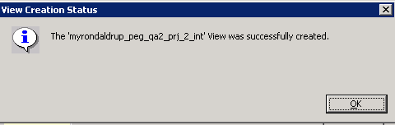
Back at the explorer window, click the ‘Views’ tab at the bottom of the left pane.
Click on the ‘View’ menu and choose ‘Refresh View Shortcuts’
You should now be able to see the new view in ClearCase.

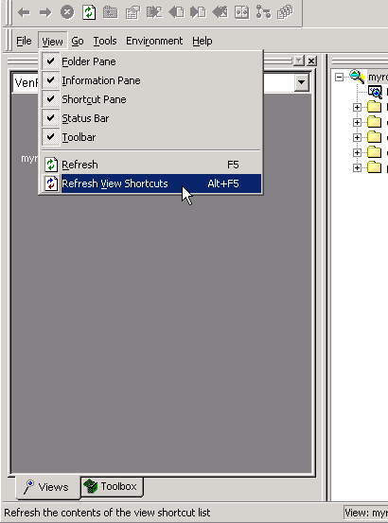

NOTE FOR THE USE OF CONNECTION SCRIPTS ON CITRIX
If you use a connection script on Citrix:
- Close ClearCase
- Log off Citrix
- Log back on to Citrix
- You should now be able to run your connection ‘.cmd’ successfully

