Purpose. The following describes how to setup and manage ClearCase Snapshot.

It includes instructions for the following:
  - Creating a New Snapshot View
  - Updating a Snapshot View
  - Removing a Dynamic View

Creating a Snapshot View

The following describes how to setup a new Snapshot View. A Snapshot creates a physical copy of the project on the drive you designate. If this is the first time you are creating a Snapshot View for your Project, you will need to first remove any existing Dynamic View you have for that Project. (See “Removing a Dynamic View” at the end of this How-To to perform this action)

- To create a Snapshot View, open ClearCase Explorer by going to:

Start > All Programs > IBM Rational > IBM Rational ClearCase > ClearCase Explorer

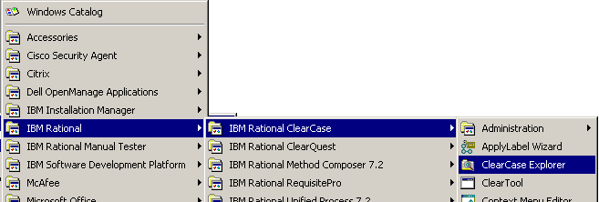

- In ClearCase Explorer (on the left side), click on Toolbox (tab) at the bottom, and select UCM in the dropdown. After UCM is selected, click on Join Project:

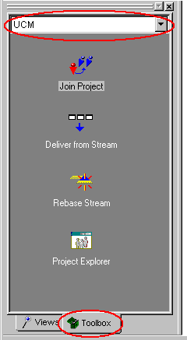
- In the Join Project dialog, click on “Show all Project VOBs”, and expand the Project you want to join:

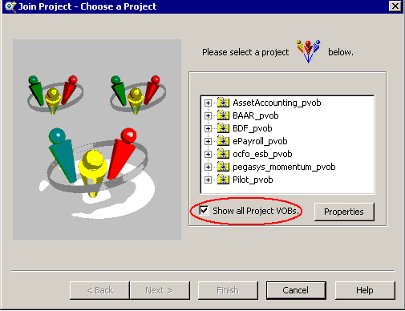

Highlight your project and click Next:

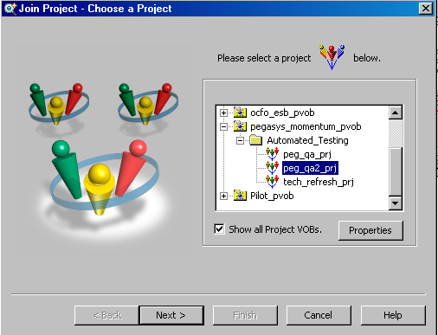

- Select Snapshot view and click Next:

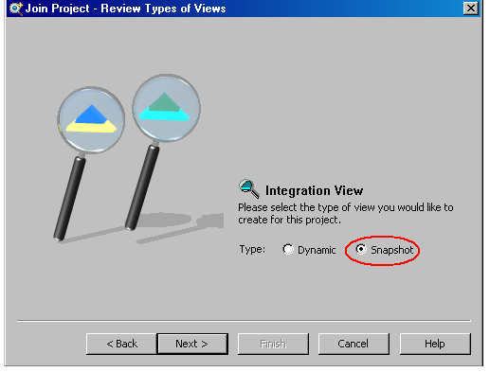

- On the “Choose Location”,
  - If on a Citrix server, choose or browse to D:\Ratl_Local, and leave the default view name selected based on the selected Project. Your path name should match the following convention: D:\Ratl_Local\[Your ENT ID ALL lowercase]_[Project Name]_int
  - If you have ClearCase installed locally on your computer, choose your H: drive (personal network drive) or your C: drive.

Example: D:\Ratl_Local\joesmith_ peg_qa2_prj_int
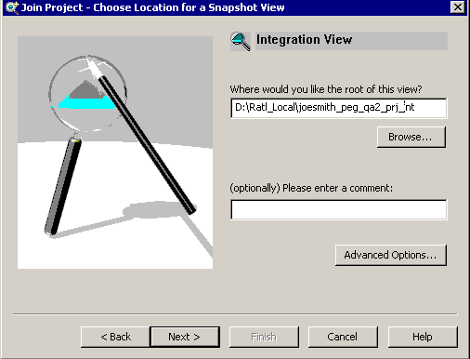

Then, Click Next

6.) Leave the default components checked. For example, for FEDdesk, leave the FEDDESK_doc checked: At this point, you could choose to download all or only part of the project. To choose to download specified objects, click ‘Start component browser after creating the view’
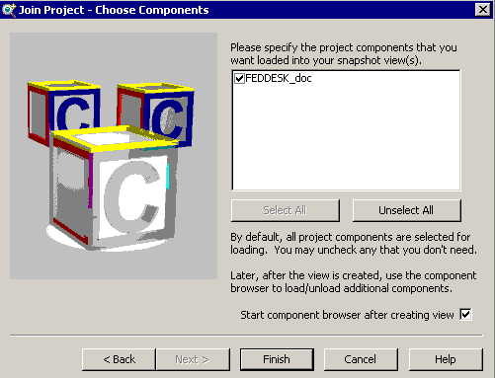

Click Finish, and then OK on the confirmation dialog.

Now, the Project will download to your snapshot view. This may take up to 10 min to download your files. However, this initial download is a one-time task.

If you had chosen to download only part of the project, it will open the following window. Move what you want to download from the left to the right window and click OK.

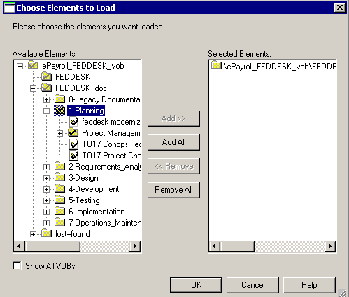

7.) Following the download of the project, you will receive confirmation that the files downloaded.

The main difference between Dynamic and Snapshot views is that a Snapshot view must be periodically updated. In order to have the most current information and/or to make permanent changes, you must update the view. You do this from the Explorer or inside of Clearcase.

You should refresh your Snapshot in each of the following situations:
- Daily
- Just before you check out files
- Just after you check in files

Updating an Existing Snapshot View

Updating a Snapshot view via Explorer.
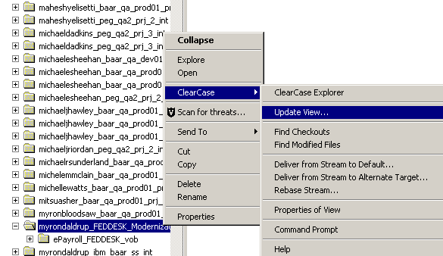

Updating a Snapshot view via ClearCase
- To Update a Snapshot View, open ClearCase Explorer by going to:
Start > All Programs > IBM Rational > IBM Rational ClearCase > ClearCase Explorer

- In ClearCase Explorer (on the left side), click on Views (tab) at the bottom, and then select your Project in the dropdown:

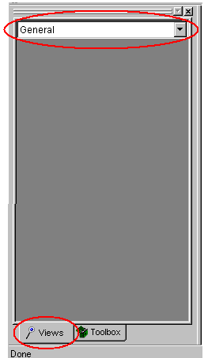

- Right click on the view in the display, and select “Update View”:

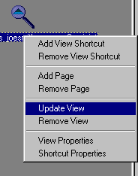
This will start the update process to download the latest scripts from the repository.

Removing a Dynamic View

If you have an existing Dynamic View, remove it using the following instructions. Before removing the View, make sure you have all scripts checked in from your View.

- To remove a View, open ClearCase Explorer by going to:
Start > All Programs > IBM Rational > IBM Rational ClearCase > ClearCase Explorer

- In ClearCase Explorer (on the left side), click on Views (tab) at the bottom, and then select your Project in the dropdown:

- Right click on the view in the display, and select “Remove View”:

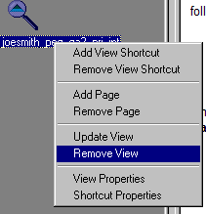
Then wait for the process to complete.

