**RECERTIFICATION VIA CQWEB**

**Change Log**

**Created 3/27/2018 ……………………………………… Myron Daldrup**

**Updated 10/17/2019 ……………………………………… Myron Daldrup**

Table of Contents

EARS - RE-CERTIFICATION ACTIONS 3

CQWEB – LOG-ON AND CHOOSE ACCESS REQUEST (User/Manager) 4

CQWEB - REQUEST RE-CERTIFICATION FOR ACCESS (User) 5

CQWEB - APPROVE RE-CERTIFICATION FOR ACCESS (Manager) 6

# EARS - RE-CERTIFICATION ACTIONS

You can recertify many of Rational accesses via the EARS (Employee Access Request System) application.

Go to: https://ears.ocfo.gsa.gov/ears/faces/

Log on either via your PIV card or ENT credentials

Perform the required action

For how to request or approve re-certification in EARS, instructional documents can be found on the web site by using either:

The ‘Help/FAQ’ tab of the web site

or

Directly accessing the url: <https://ears.ocfo.gsa.gov/ears/faces/help.jsp>

# CQWEB – LOG-ON AND CHOOSE ACCESS REQUEST (User/Manager)

The web application URL is: https://esc.finance.gsa.gov/cqweb/

Log onto CQWeb

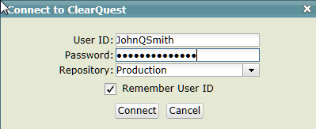

Choose the ‘ESC01’ database

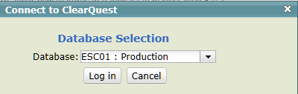

Enter either the full request number or the last digits of value in the upper left of the screen and press ‘Search’.

Ie. Full number below is ‘ESC0100065201’ but only ‘65201’ is required.

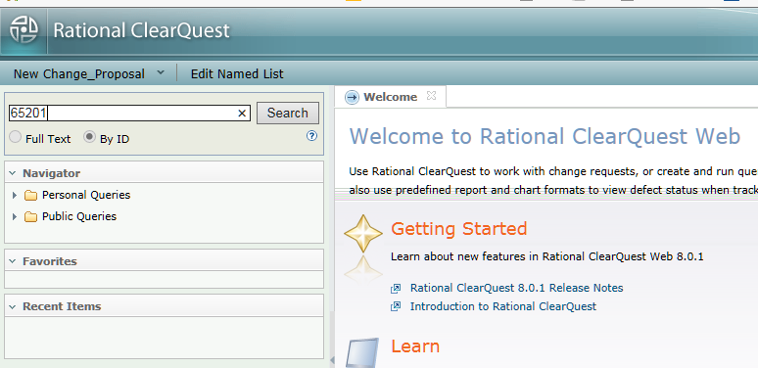

# CQWEB - REQUEST RE-CERTIFICATION FOR ACCESS (User)

The request should open and be in the ‘Pend_Recert_Rqst’ state.

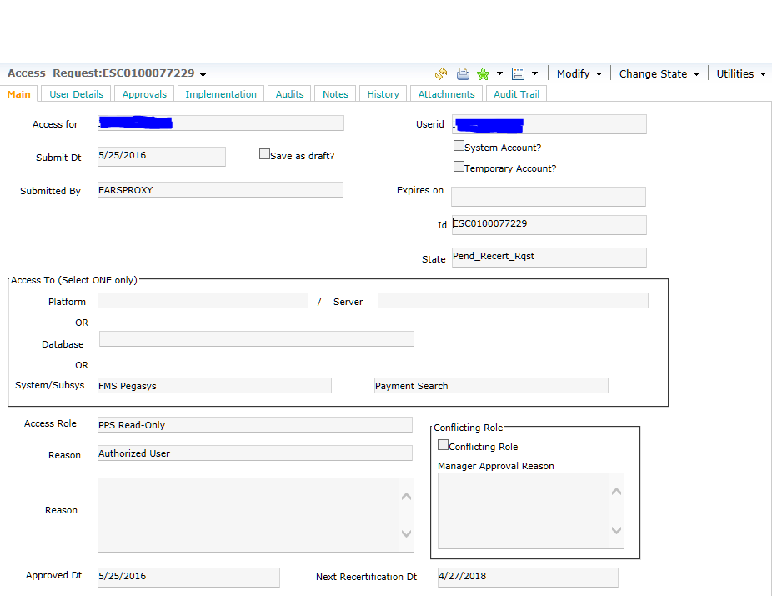

Open the ‘Change State’ menu and choose the ‘Rqst_Recert’ action

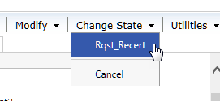

Then, choose the ‘Save and Close’ menu.



# CQWEB - APPROVE RE-CERTIFICATION FOR ACCESS (Manager)

The request should open and be in the ‘In_Recertification’ state.

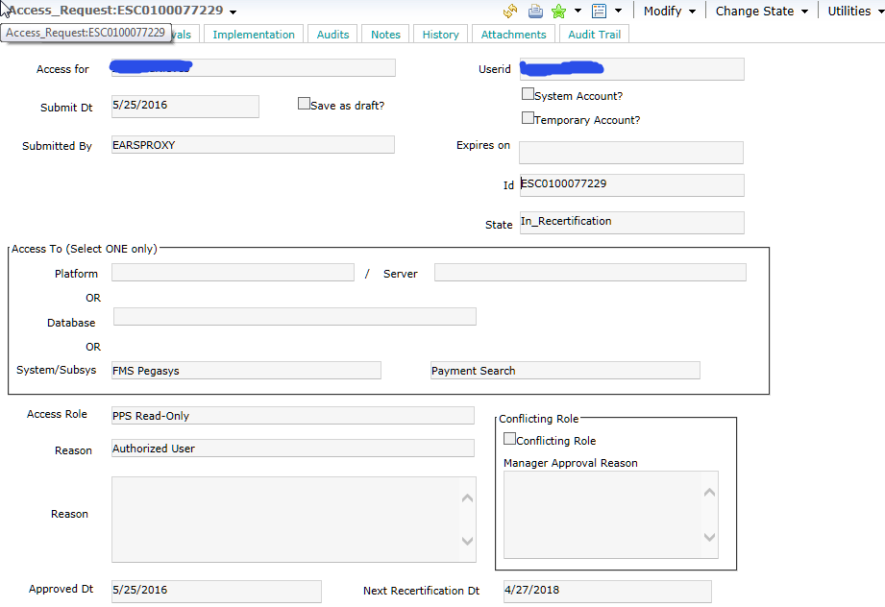

Open the ‘Change State’ menu and choose the ‘Recertify’ action

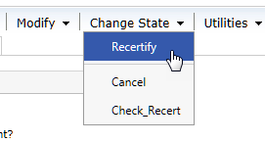

Then, choose the ‘Save and Close’ menu.

